Intro

1. *List 3 different protocols that appear in the protocol column in the unfiltered packet-listing window in step 7 above.*
   1. **HTTP, DNS, TCP, UDP**
2. *How long did it take from when the HTTP GET message was sent until the HTTP OK reply was received?*
   1. HTTP GET request showed that the packet arrived at 29.206995 seconds.
   2. HTTP OK was received at the arrival time of 29.230996 seconds.
   3. The time it took was **0.024001 seconds.**
3. *What is the Internet address of the gaia.cs.umass.edu (also known as www-net.cs.umass.edu)? What is the Internet address of your computer?*
   1. **IP address of gaia.cs.umass.edu is 128.119.245.12**
   2. **My local address is 141.215.202.201**
4. *Print the two HTTP messages (GET and OK) referred to in question 2 above.* 
   1. HTTP GET:

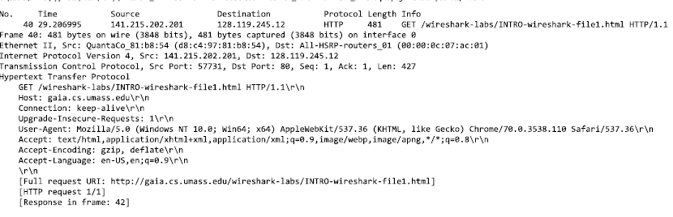

* 1. HTTP OK:

